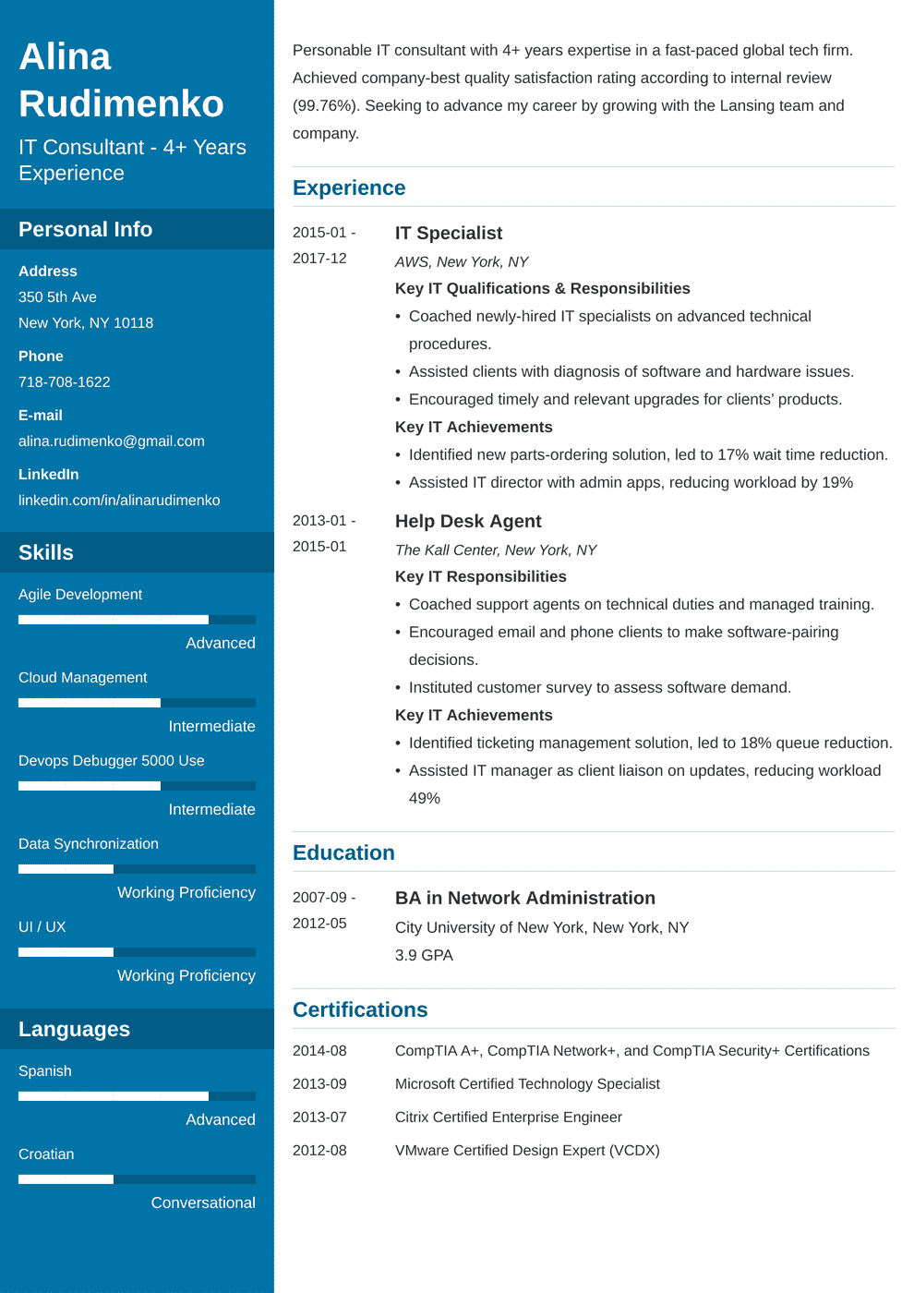
Alina
Rudimenko
IT Consultant - 4+ Years
Experience
Personable IT consultant with 4+ years expertise in a fast-paced global tech firm. Achieved company-best quality satisfaction rating according to internal review (99.76%). Seeking to advance my career by growing with the Lansing team and company.
Experience
Personal Info
Address
350 5th Ave
New York, NY 10118
Phone
718-708-1622
E-mail
alina.rudimenko@gmail.com
LinkedIn
linkedin.com/in/alinarudimenko
Skills
Agile Development
Advanced
Cloud Management
Intermediate
Devops Debugger 5000 Use
2015-01-
IT Specialist
2017-12
2013-01-
2015-01
Intermediate
Data Synchronization
Education
Working Proficiency
UI / UX
2007-09 - 2012-05
Working Proficiency
AWS, New York, NY
Key IT Qualifications & Responsibilities
• Coached newly-hired IT specialists on advanced technical procedures.
• Assisted clients with diagnosis of software and hardware issues.
• Encouraged timely and relevant upgrades for clients' products. Key IT Achievements
• Identified new parts-ordering solution, led to 17% wait time reduction.
• Assisted IT director with admin apps, reducing workload by 19%
Help Desk Agent
The Kall Center, New York, NY
Key IT Responsibilities
• Coached support agents on technical duties and managed training.
• Encouraged email and phone clients to make software-pairing decisions.
⚫ Instituted customer survey to assess software demand. Key IT Achievements
• Identified ticketing management solution, led to 18% queue reduction.
• Assisted IT manager as client liaison on updates, reducing workload 49%
BA in Network Administration
City University of New York, New York, NY
3.9 GPA
Languages
2014-08
Spanish
2013-09
Certifications
CompTIA A+, CompTIA Network+, and CompTIA Security+ Certifications
Microsoft Certified Technology Specialist
Advanced
2013-07
Citrix Certified Enterprise Engineer
Croatian
2012-08
VMware Certified Design Expert (VCDX)
Conversational

